ADVERTISEMENT FOR MSC SCHOLARSHIPS UNDER THE FACILITY FOR ACTION FOR CLIMATE EMPOWERMENT TO ACHIEVE NATIONALLY DETERMINED CONTRIBUTIONS (FACE NDC) PROJECT
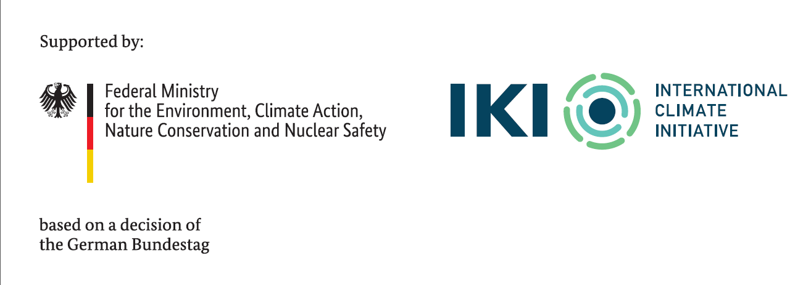
CALL FOR APPLICATION FOR MSC SCHOLARSHIPS UNDER THE FACE-NDC PROJECT AT THE COPPERBELT UNIVERSITY FOR JULY 2026 INTAKE
The Copperbelt University, through the School of Natural Resources and the School of Engineering, is one of the five consortium partners in the Facility for Action for Climate Empowerment to Achieve Nationally Determined Contributions (FACE-NDC) Project, with implementation timeline from 2023 to 2030. Other partners include: The Food and Agriculture Organisation (FAO), United Nations Educational, Scientific and Cultural Organization (UNESCO), United Nations Institute for Training and Research (UNITAR) and the University of Zambia (UNZA). FAO is the lead partner, whereas the International Climate Initiative (IKI) from Germany is the principal funder. The FACE-NDC project seeks to empower the Zambian society to achieve the Nationally Determined Contributions (NDCs) through enabling them to adopt climate-friendly behaviours and to support transition to a green economy with a focus on three (3) sectors, namely: forestry, agriculture and energy.
As one of its goals, the FACE-NDC Project will provide 13 scholarships at the Master of Science (MSc) level for candidates to undertake their studies at the Copperbelt University in thematic areas related to sustainable agriculture. Therefore, the Copperbelt University hereby requests applications for FACE NDC scholarships for MSc studies. Recipients of these scholarships will be expected to be at the University pursuing full-time studies for the duration of their sponsored study programmes.
Eligibility criteria
The call is open to Zambian nationals only, aged 35 years and below.
Females are strongly encouraged to apply, as these scholarships will be awarded to at least 50% female applicants. Priority will also be given to candidates from disadvantaged backgrounds, including those from low-income households, underrepresented communities, and remote or rural areas.
Ineligibility
The following are not eligible to apply for the FACE NDC scholarships:
- Public service employees, including Government Ministries or other statutory institutions.
- Students already enrolled at the Copperbelt University.
Requirements:
- Possess a Bachelor’s Degree from relevant fields, including agroforestry, agriculture, crop science, and agronomy.
- Admission into the MSc Sustainable Agriculture programme. On or before the Scholarship Application Deadline, one should have been admitted unconditionally (except for funding) for the upcoming academic year to at least one of the proposed programmes linked to the project.
- At least two (2) recommendation letters, with one from a previous academic supervisor, highlighting the applicant's academic and research capabilities.
- A curriculum vitae showing demonstrated research experience through publications, conference presentations, or research projects.
- Research concept. Demonstration of research interest and potential through a well-crafted concept note of not more than 500 words that will include the research questions, objectives, and methodology.
- Motivation letter: An articulate statement outlining the academic and career goals, and how the scholarship will contribute to your aspirations.
Scholarship value
This scholarship covers:
- 50% of the tuition fees
- Research grant (paid in the fourth semester of study, upon successful defense of the Master’s thesis proposal)
- Minimal living allowance paid once a year

Submission of Application
The application for the scholarship should be addressed to the undersigned and submitted not later than 17th July, 2026.
Note that the shortlisting of applicants will be done within two weeks of the closing date. Shortlisted candidates will be interviewed by a panel consisting of members of staff from CBU and FAO.

The Coordinator,
FACE NDC Project,
Copperbelt University,
School of Natural Resources,
P.O. Box 21692,
Kitwe

Applications shall be made through Email only to dean.snr@cbu.ac.zm and copied to; gillian.kabwe@cbu.ac.zm; face-ndc@fao.org
If there is any clarification, technical and administrative support that is required, applicants may contact Prof. G. Kabwe on +260 974 355 949 and/or email: gillian.kabwe@cbu.ac.zm

All candidates will be informed of the outcome of their application. The University will also publish the list of selected candidates on the University’s website and other official social media platforms.






